**(Agile meaning is Flexible and fast)**

**Agile Model/Agile Process/Agile methodology:**

***Burndown Chart:***

It is a graphical representation of work left vs time.

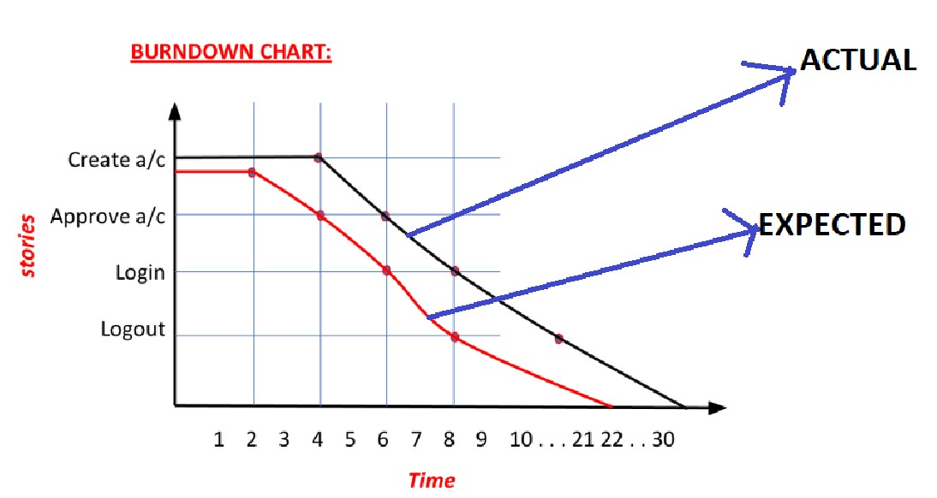

***Storyboard/White Board:***

It is a board which contains a list of pending tasks, tasks in progress and completed tasks.

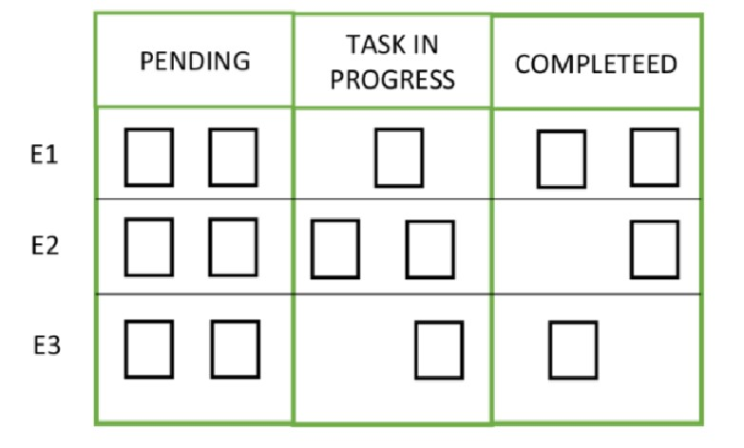

***Chicken***

It is one who observes and tries to understand how sprint is going on and he will not be doing any task

***Story point***

It is estimation of how long task would take to complete or how long story is going to take to develop and test

***Hot Fix/ Incident Management:***

* In the production if the customer faces any blocker or critical defects it will be communicated to the company, developers will immediately fix the defect and TE will retest and patch will be created & it will be installed in the production server.
* This is called as Hot Fix or Incident management. • This may take up to 3 hours or 3 days.

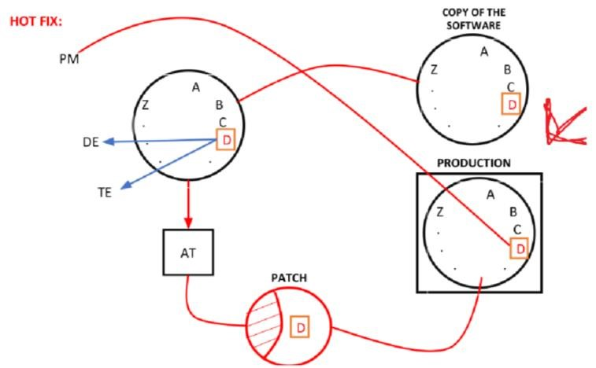

***Root Cause Analysis:***

· Here the entire team sits together and finds the root cause of the defect and shares it in a common folder where everyone can access it & present it to the entire team.

· This technique is called Fish bone technique or Ishikawa method or RCA meeting

(Root Cause Analysis)

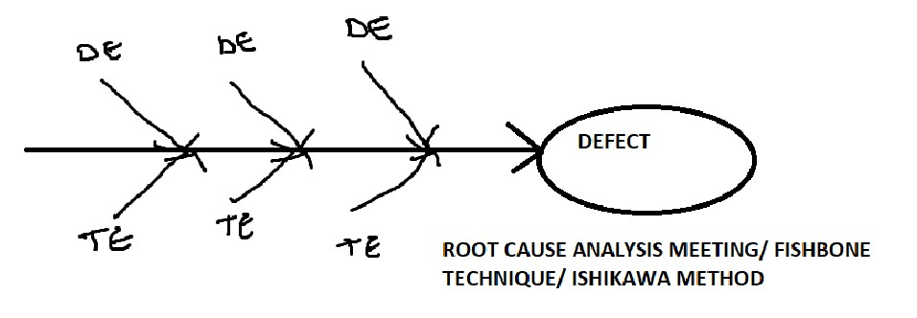

**Multiple Scrum Teams:**

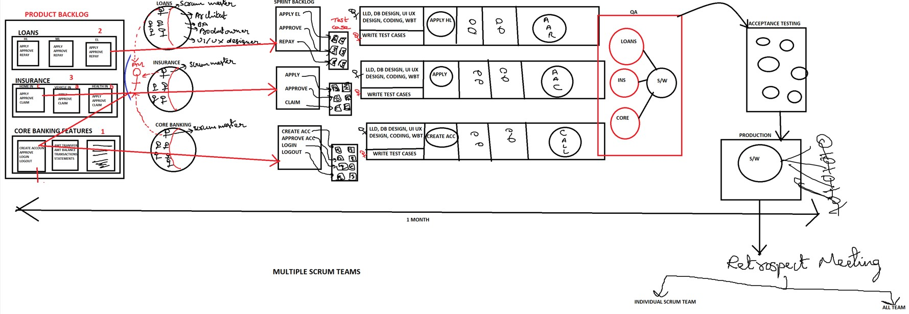

Epic:

Complete set of requirement is called as Epic. Epic will be created by Scrum Master or BA in project management tool called 'Jira'.

Story/User Story/ Story card

Stories are nothing but features/Modules/Functionalities.

One Epic can consist of multiple stories.

Story point

Story point is a rough estimation given by Developers and Test engineers to develop and test every individual stories.

Based on what TestingTeam will give estimation for the story:

-------------------------------------------------------------

Time taken to understand the requirement

+

Time taken to write test scenarios

+

Time taken to write Test cases

+

Time taken to Review test cases

+

Time taken for Test Execution

+

Time Taken for Defect Tracking

Based on what Developement Team will give estimation for the story:

-----------------------------------------------------------------

Time taken to understand the requirement

+

Time taken to do the Design

+

Time Taken to write the code

+

Time Taken to do WBT

+

Time Taken to do Code Review

+

Time Taken to Fix the defect.

Swag:

Swag is a rough estimation given by Developers and Test engineers to develop and test every individual stories in the form of hours.

Sprint:

It is the actual time spent by Developers and Test engineers to develop and test one or more stories.

what are the meetings/Scrum Ceremonies done in Scrum model?

Scrum Meetings/Scrum Ceremonies(4 meetings are there)

who can become scrum master

Answer: Sr TE, Sr Dev, BA, PM and customer (some times) can become scrum master.

Bug Triaging or defect triage meeting:

It is the meeting conducted by the TE or BA or Scrum master a week before the Release or few days before the sprint Dev,TE, BA and scrum master will be present in this meeting.

In this meeting we collect list of all the pending and open defects which are not fixed by developers in current project from customer business point of view and decide which bugs should be fixed in current Release/Sprint and which bug Triage Meeting.

Bug Bucket:

It is an Epic or story created by the scrum master or BA in the project management Tool Jira.

This Bug Bucket will be handled as a part of every Release.

Bug Bucket consist of list of all the pending defects which are not fixed by the developers.

what is 'CHICKEN' and what is 'PIG'

In Agile----> 'CHICKEN' and what is 'PIG'(both are the words used for scrum team members)

PIG: Pigs are the scrum team members. These are the people who are committed to the project , work on the project

Example: TE, DEV, BA etc....

Chickens:

Chickens are the people who get the business to the company and get the work done from the team members.

Example: Management Team, Customers, Stake holders etc....

Zero sprint:

Zero Sprint is a pre planning sprint to get ready for the Actual Sprint. ex: Deciding which technology, Infrastructure, System configuration.

Spike:

Spike is also an issue, where as spike cannot be treated as a story because of lack of clarity on the given task.

-----------------------------------------------------

Note :( Process will change from company to company and from project to project)

Burn down chart:

Burn up Chart:

This chart is used to calculate total amount of work completed at the end of the every sprint.

what is velocity and capacity in Agile?

capacity: Total amount of available hours of every individual engineers for the given sprint is called as capacity

velocity: Total amount of work completed by every individual engineers in the givensprint is called as velocity (95 hrs)

or

velocity is the measurement of average amount of story points delivered to the customer in the given sprint.